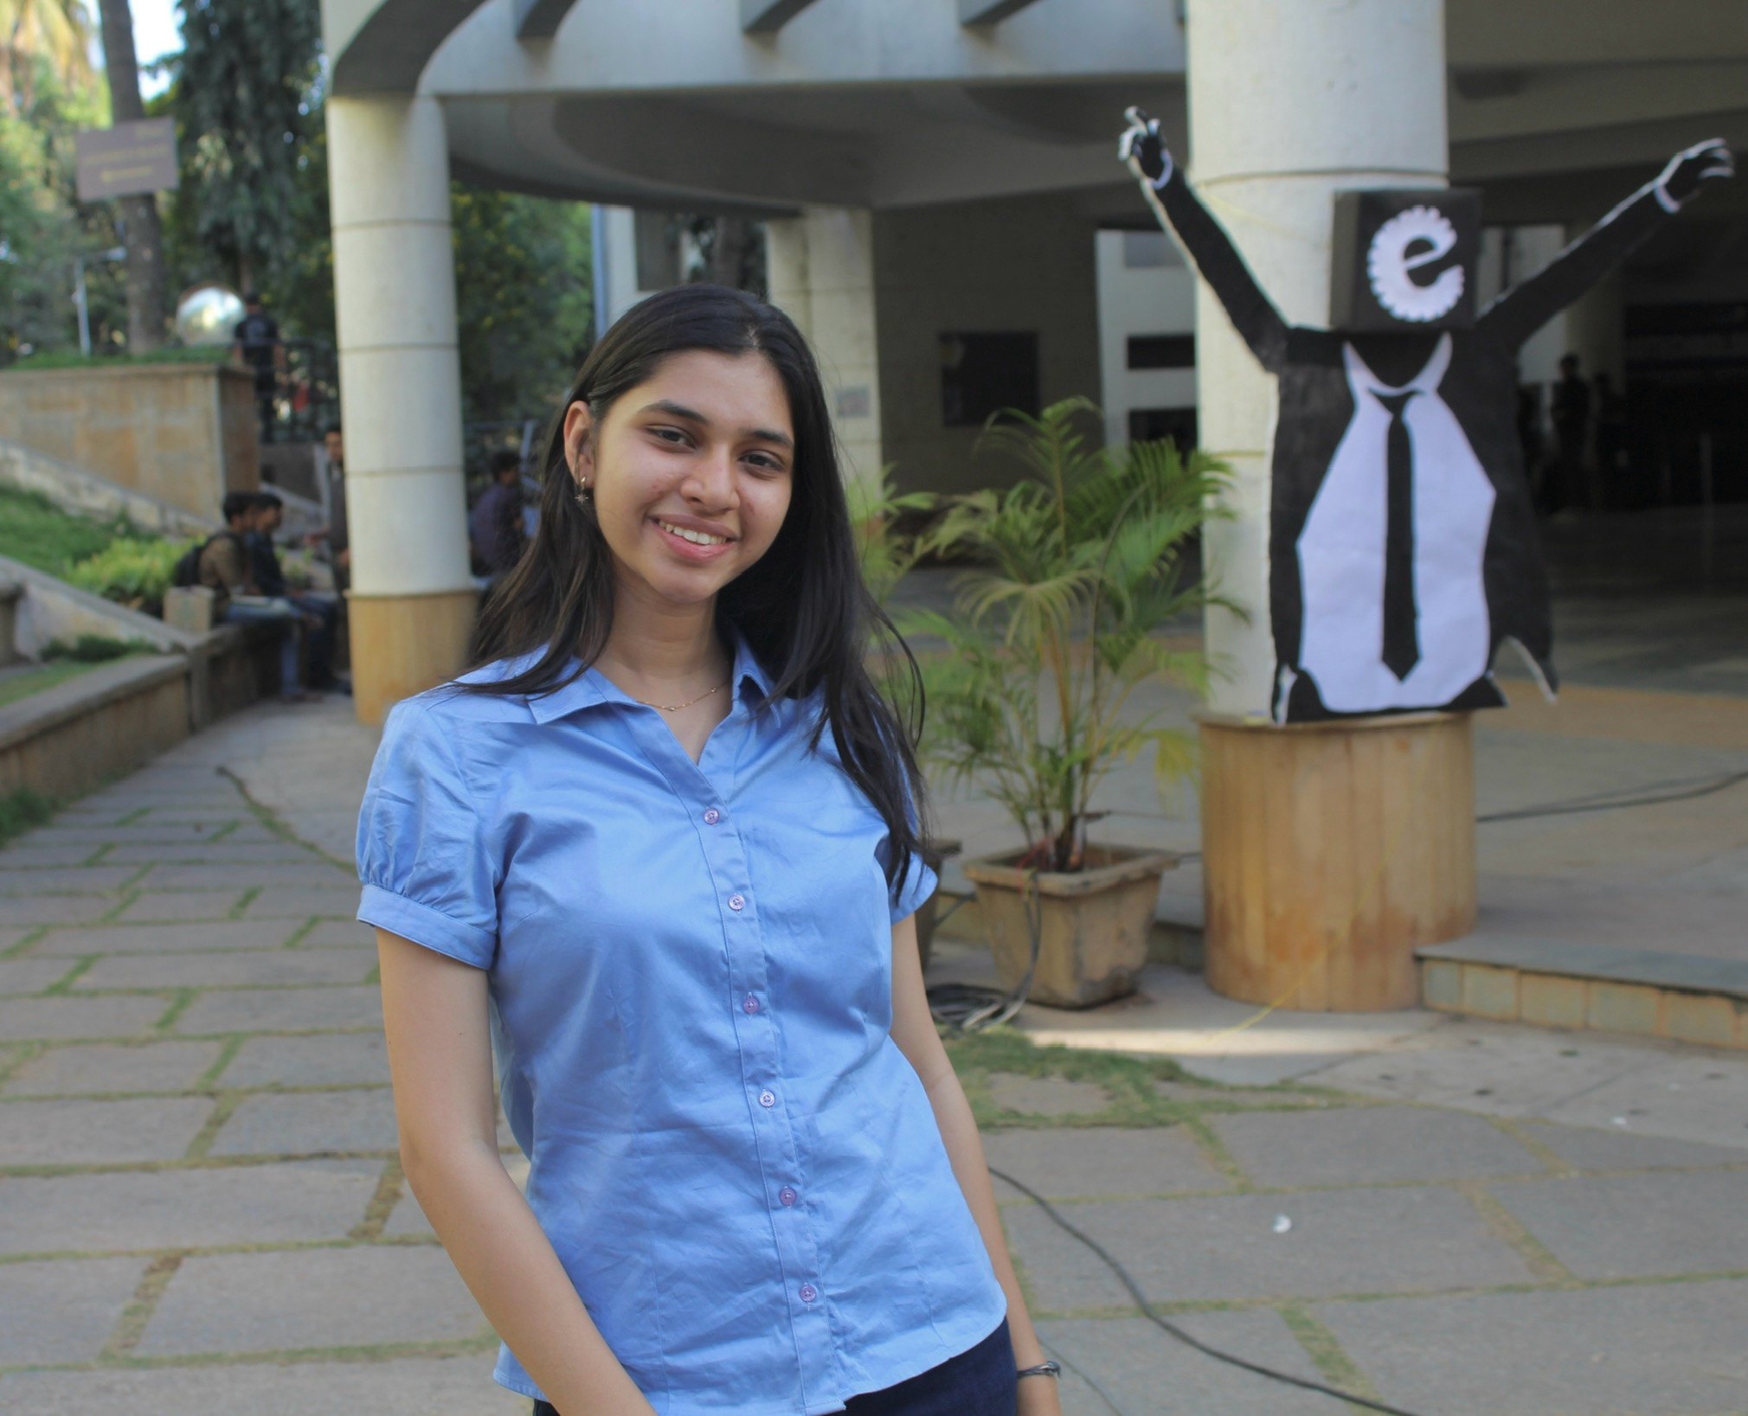

INSTAGRAM HANDLE @pranatihota09 [pranatihota09](https://www.instagram.com/pranatihota09/#)

https://www.instagram.com/pranatihota09/#

LinkedIn PROFILE LINK https://www.linkedin.com/in/pranati-hota-b75759271